

|  |
| --- |
|  |
|  |
|  |
|  |
| **Yotpo**  **Salesforce Commerce Integration** |
|  |
| ***Yotpo Link Version 19.1.0*** |
|  |
|  |
|  |
|  |
|  |
|  |
|  |
|  |



Contents

1. Summary 3

2. Component Overview 4

2.1 Functional Overview 4

2.2 Use Cases 4

2.2.1 Use Case # 1: Product Review Widget 4

2.2.2 Use Case # 2: Star Rating Widget 4

2.2.3 Use Case # 3: Automatic Review Requests (post purchase review request emails) 4

2.3 Limitations, Constraints 4

2.4 Compatibility 4

2.5 Privacy, Payment 5

3 Implementation Guide 6

Prerequisites 6

3.1 Setup 6

3.2 Configuration 6

3.2.1 Cartridge Registration 6

3.2.1.1 Site 6

3.2.1.2 Business Manager 6

3.2.2 Import Yotpo Metadata Services and Jobs Schedules: 8

3.3 Job Details 8

3.4 Services Details 8

3.4.1 Authentication Service 8

3.4.2 Export Purchase Service 8

3.5 Template Overrides 10

3.6 External Interfaces 10

3.7 Testing 10

4 Operations, Maintenance 11

4.1 Data Storage 11

4.2.1 Order Custom Attributes 11

4.2 Availability, Service Failure, and Recovery 11

4.3 Support 11

5 User Guide 12

5.1 Roles, Responsibilities 12

5.1.1 Permission Grant on Yotpo Module 12

5.2 Business Manager 12

5.2.1 Yotpo Site Preferences 12

5.2.2 Set up the Yotpo Configurations 14

5.3 Storefront Functionality 14

6 Known Issues 15

7 Release History 16

# Summary

Yotpo’s suite of integrated solutions for user-generated content marketing, loyalty, and referrals helps commerce companies accelerate growth by enabling advocacy and maximizing customer lifetime value. With Yotpo, brands can effectively leverage social proof to increase trust and sales, cultivate loyal customer advocates, and make better business decisions based on customer feedback.

This document provides technical instructions for installing and using Yotpo Salesforce Commerce Link Cartridge, which enables you to integrate various Yotpo features within a Salesforce Commerce storefront.

Clients using the Yotpo Salesforce Commerce Link Cartridge can access the following features:

1. Product Review Widget
2. Star Rating Widget
3. Automatic Review Request Emails

In order to use the Salesforce Commerce Link Cartridge, customers must be in contract with Yotpo.

# Component Overview

## Functional Overview

Following is the list of features implemented in the Yotpo Link cartridge integration:

* Product Widgets
  + Product Review Widget.
  + Star Rating Widget.
* Automatic Review Request Emails
  + Order export
* Analytics.
  + Purchase conversion tracking.

## Use Cases

### Use Case # 1: Product Review Widget



|  |  |
| --- | --- |
| **Use Case Scenarios** | **Result** |
| The merchant implements Product Review Widget in a page or pages in the store. | The user will be able to see Product Review Widget on those store pages. |

### Use Case # 2: Star Rating Widget

|  |  |
| --- | --- |
| **Use Case Scenarios** | **Result** |
| The merchant add Star Rating Widget on Product or Category Landing Page in the store. | The user will be able to see a Star Rating Widget on those store pages. |

### Use Case # 3: Automatic Review Requests (post purchase review request emails)

|  |  |
| --- | --- |
| **Use Case Scenarios** | **Result** |
| The merchant schedules the job that sends the order data to the Yotpo API. | The user’s customers will receive review request emails according to the Yotpo account configuration. |

## Limitations, Constraints

Use of the Yotpo LINK cartridge by itself does not grant nor enable use of Yotpo product offerings. Yotpo must separately come to a contractual agreement with the client in order for Yotpo to start collecting reviews on their behalf. Please contact Yotpo for details: <sales@yotpo.com>.

## Compatibility

The Yotpo LINK cartridge is compatible with StoreFront Reference Architecture version 4.2.1 or later.

## Privacy, Payment

Masked Order Information and Aggregate Sales Information may be captured as part of purchase tracking implementation on the site.

No customer specific profile data or sensitive information will be stored related to Yotpo LINK cartridge.

The Yotpo LINK cartridge itself is available free of charge. See "Limitations, Constraints" section for details regarding potential costs involved with enabling Yotpo to start collecting reviews on your behalf.

In using the Yotpo LINK cartridge, you agree to be bound by our [Terms of Service](https://www.yotpo.com/terms-of-service/).

# Implementation Guide

## Prerequisites

A Yotpo representative must enable an account for the merchant, as part of which the merchant will be assigned a unique “app key” and “client secret key”.

## 3.1 Setup

The Yotpo LINK integration uses the following cartridges: **int_yotpo_sfra** and **bm_yotpo**

## Configuration

### Cartridge Registration

Navigate to the following path "Sites **🡪** Manage Sites **🡪**  **<Merchant Site>** **🡪**  Settings"

Add the cartridge names to Cartridges path as shown in screenshot below:

#### Site

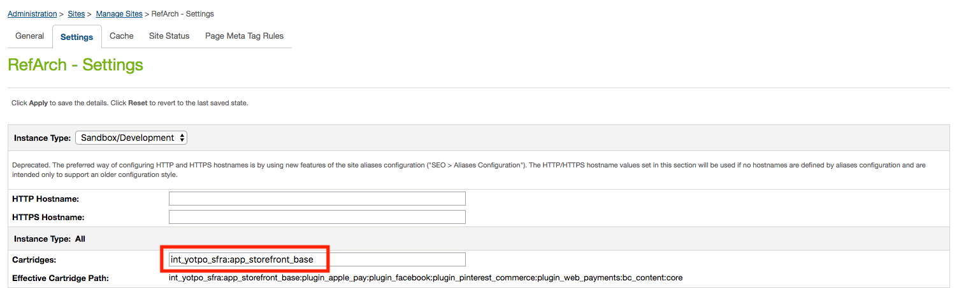

#### Business Manager

The Yopto cartridge includes a custom interface for managing account configurations in Business Manager.

Navigate to the following path "Sites **🡪** Manage Sites **🡪**  **Business Manager**" 🡪 Settings

Add the cartridge names to Cartridges path as shown in screenshot below:

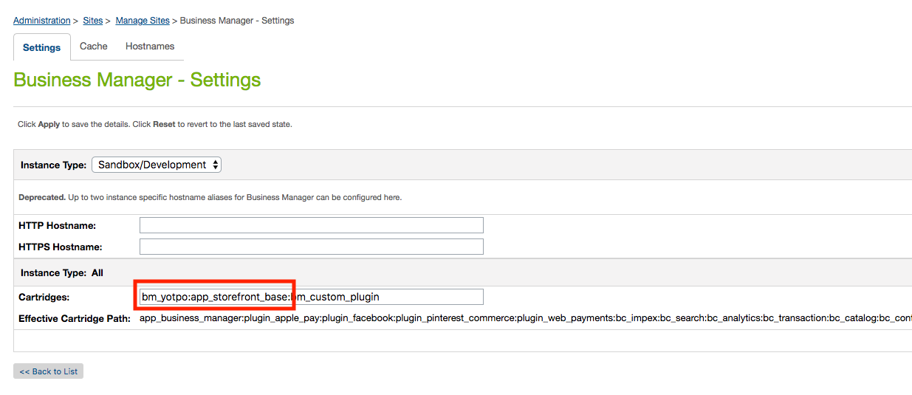

### Import Yotpo Metadata Services and Jobs Schedules:

Get the metadata.zip file from Yotpo cartridge’s Metadata folder

* Navigate to Site Development **🡪** Site Import & Export.
* Select metadata.zip file and click on ‘Import’ and complete the import process through the interface.
* The Jobs, Services, Site Preferences, Custom Objects will be imported including Yotpo Configurations and Yotpo Jobs Configurations.
* The details on job schedules and services is described in section 3.3 and 3.4 respectively.
* The details on Yotpo Custom Preferences is described in section 5.2.1. For further details on Yotpo account configurations see section 5.2.2 and 5.2.3.

## Job Details

|  |  |
| --- | --- |
| Name | Description |
| Yotpo Order Export | This job uses the Jobs Framework provided by Commerce Cloud. It transfers the purchase feed to Yotpo. |

**Note:** A basic configuration for this job is included in the site import. However, the correct sites must be configured. This configuration is located under the “Scope” section inside of the “Job Steps” tab.

## Services Details

Navigate to Administration **🡪** Services.

After successfully importing services, following will be added:

|  |  |  |
| --- | --- | --- |
| Name | Profile | Credentials |
| int_yotpo_sfra.https.post.auth.api | int_yotpo_sfra.rest.api.profile | int_yotpo_sfra.https.post.auth.api.cred |
| int_yotpo_sfra.https.post.export.purchase.api | int_yotpo_sfra.rest.api.profile | int_yotpo_sfra.https.post.export.purchase.api.cred |

### Authentication Service

URL for authentication token API could be set in *int_yotpo_sfra.https.post.auth.api.cred*

|  |
| --- |
|  |

**Note:** User and Password not required.

### Export Purchase Service

URL for Export Post API could be set in *int_yotpo_sfra.https.post.export.purchase.api.cred*

|  |
| --- |
|  |

**Note:** User and Password not required. Also the **[appKey]** will be dynamically replaced in the code when making a service call.

## Template Overrides

Several SFRA templates are overridden as a part of the int_yopo_sfra cartridge:

*“/int_yotpo_sfra/cartridge/templates/default/product/components/descriptionAndDetails.isml”*

*“/int_yotpo_sfra/cartridge/templates/default/product/components/productRating.isml”*

*“/int_yotpo_sfra/cartridge/templates/default/product/components/ratings.isml”*

*“/int_yotpo_sfra/cartridge/templates/default/checkout/confirmation/confirmation.isml”*

**Note:** If any of these templates are also overwritten by another cartridge, you will have to merge the changes from that cartridge with the changes made in the Yotpo version of the template. The recommended approach is to create a separate cartridge which contains only the merged templates.

## External Interfaces

There are no external interfaces

## Testing

To see a demo of product reviews and Star Rating visit the following pages:

<https://yotpo01-tech-prtnr-eu03-dw.demandware.net/s/RefArch/bootleg-pant/25591026M.html?lang=en_US>

<https://yotpo01-tech-prtnr-eu03-dw.demandware.net/s/RefArch/search?q=Bootleg&search-button=&lang=en_US>

# Operations, Maintenance

## Data Storage

### Order Custom Attributes

|  |  |  |
| --- | --- | --- |
| **Attribute Definitions** | | |
| **ID** | **Name** | **Type** |
| userAgent | User Agent | String |
| userIPAddress | User IP Address | String |
| **Attribute Grouping** | | |
| **ID** | **Name** | |
| YotpoAttributes | Yotpo Attributes | |

## Availability, Service Failure, and Recovery

Yotpo services are based on a high-availability infrastructure and have 99.9% uptime.

If the Yotpo endpoints go down:

* If your pages are unable to get reviews and from their servers, the Yotpo reviews and Star Rating will simply not show, it won’t degrade or break your page in any way.
* If your Purchase Feed is unable to be received by their servers it will attempt to resend it up to five times in a single job run. If all attempts fail the job last executed date will not be updated so any missed orders will be resent on subsequent job runs until the service is available.

## Support

Contact [Yotpo Support](https://my.yotpo.com/contact_support) regarding this LINK cartridge.

# User Guide

## Roles, Responsibilities

Yotpo Export Orders job should be scheduled to run at least once daily.

Make sure **enablePurchaseFeed, enableReviews** and **enableRatings** is enabled in

“Merchant Tools **🡪** Custom Objects **🡪** Custom Objects Editor **🡪** Yotpo Configurations for a specific locale to make ratings, reviews or conversation tracking work.

### Permission Grant on Yotpo Module

The permission to access the Yotpo module needs to be granted to a specific role. Navigate to following path:

Administration 🡪 Organization 🡪 Roles & Permissions

Select the specific role needs to be granted e.g. Administrator and open the Business Manager Module tab as shown below in the screenshot;

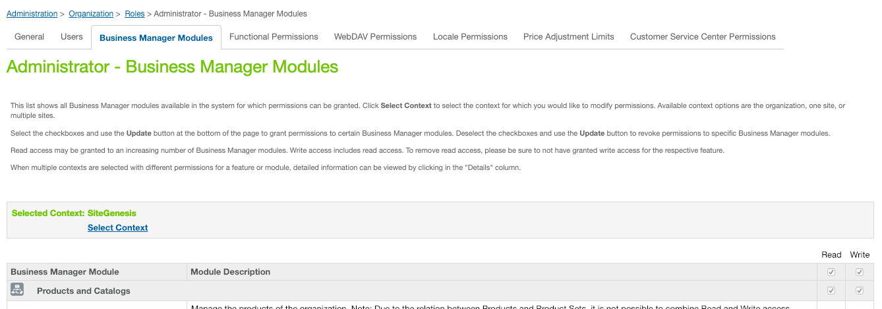

Select the specific site in Select Context and click Apply. Scroll down to Yotpo Swell Login module and select the checkbox to provide access to user role. Please see below in the screenshot for reference;

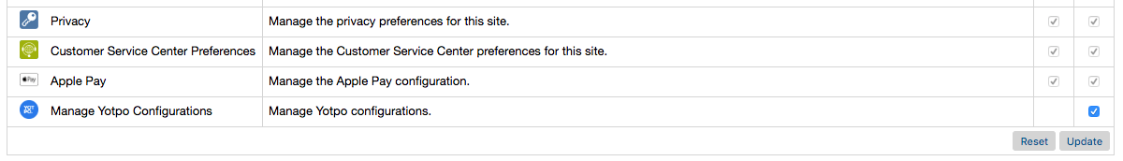

## Business Manager

### Yotpo Site Preferences

The Yotpo LINK cartridge consists of the following configuration properties in

“Site **🡪** Site Preferences **🡪** Custom Preferences **🡪** Yotpo Configurations”:

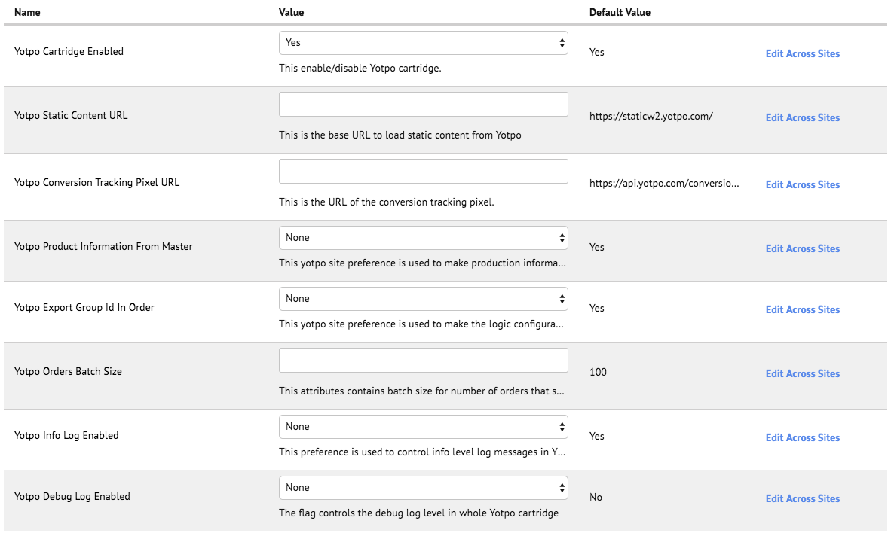

|  |  |  |  |  |  |  |  |  |  |  |  |  |  |  |  |  |  |  |
| --- | --- | --- | --- | --- | --- | --- | --- | --- | --- | --- | --- | --- | --- | --- | --- | --- | --- | --- |
| |  |  | | --- | --- | | Custom Attribute Name | Function | | Yotpo Cartridge Enabled | This attribute is used to enable or disable the yotpo cartridge | | Yotpo Static Content URL | This is the base URL to load static content from Yotpo | | Yotpo Conversion Tracking Pixel URL | This is the URL of the conversion tracking pixel. | | Product Information From Master | This site preference is used to make production information configurable whether the information will be exported from master or from variants. | | Export Group Id In Order | This site preference is used to make the logic configurable that whether the master product if will be exported in JSON or not. | | Yotpo Orders Batch Size | This attribute contains batch size for number of orders that should be processed at one time, while exporting purchase feed. | | Yotpo Info Log Enabled | The flag controls the info log level in whole Yotpo cartridge. By default, the info log will be disabled, therefore to enable the checkbox should be checked. | | Yotpo Debug Log Enabled | The flag controls the debug log level in whole Yotpo cartridge. By default, the debug log will be disabled, therefore to enable the checkbox should be checked. | |

**Note:** The default values are already set; therefore, you don’t need to change anything unless needed.

### Set up the Yotpo Configurations

Navigate to "Merchant Tools **🡪** Site Preferences **🡪** Manage Yotpo Configurations"

Select the desired Locale (Only locales enabled on your site will appear), and configure the values as appropriate

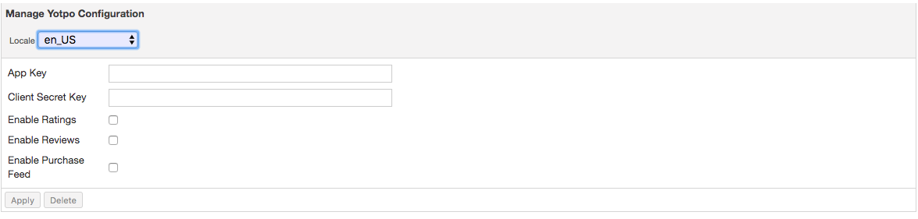

|  |  |
| --- | --- |
| Attribute Name | Function |
| Locale | The Locale ID which represents a specific account on Yotpo. |
| App Key | An App key which can be used for a specific account on Yotpo |
| Client Secret Key | A Client Secret Key which contains information for a specific account on Yotpo |
| Enable Ratings | A flag used to enable or disable ratings for the specific Locale. |
| Enable Reviews | A flag used to enable or disable the reviews for the specific Locale. |
| Enable Purchase Feed | A flag used to indicate whether the purchase feed is enabled or disabled for the specific Locale. |

## Storefront Functionality

N/A

# Known Issues

N/A

# Release History

|  |  |  |
| --- | --- | --- |
| **Version** | **Date** | **Changes** |
| **15.1.0** | 26/07/2015 | Initial Release. |
| **15.1.1** | 10/11/2015 | Added new site preference details in the document. |
| **16.1.0** | 06/6/2016 | Bug fixes and services framework implementation. |
| **17.1.0** | 24/06/17 | Migration to controller framework. Removed reviews and ratings static load feature. Added real time reviews load for product page. |
| **18.1.0** | 11/02/18 | Added SFRA compatibility for Yotpo cartridge. Replaced deprecated ServiceRegistry with LocalServiceRegistry |
| **19.1.0** | 05/01/19 | Incorporated Yotpo’s Swell Loyalty functionality in the cartridge for Controller and RFA version sites. |

